CSA5114- CRYPTOGRAPHY AND NETWORK SECURITY
LAB PROGRAMS

- Write a C program for Caesar cipher involves replacing each letter of the alphabet with the letter standing k places further down the alphabet, for k in the range 1 through 25.

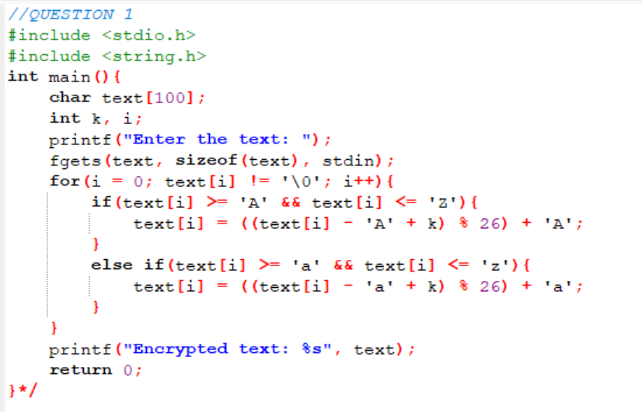
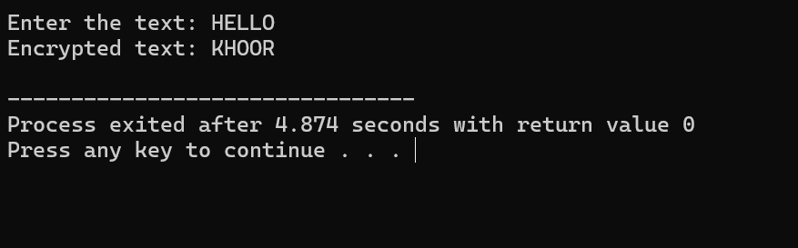

- Write a C program for monoalphabetic substitution cipher maps a plaintext alphabet to a ciphertext alphabet, so that each letter of the plaintext alphabet maps to a single unique letter of the ciphertext alphabet.

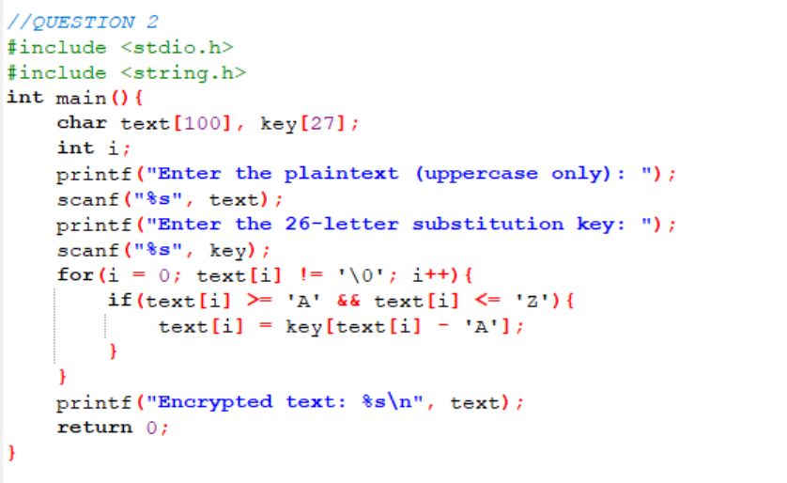
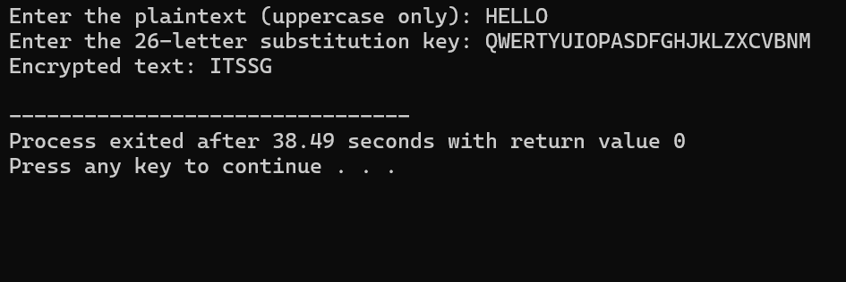

- Write a C program for Playfair algorithm is based on the use of a 5 X 5 matrix of letters constructed using a keyword. Plaintext is encrypted two letters at a time using this matrix.

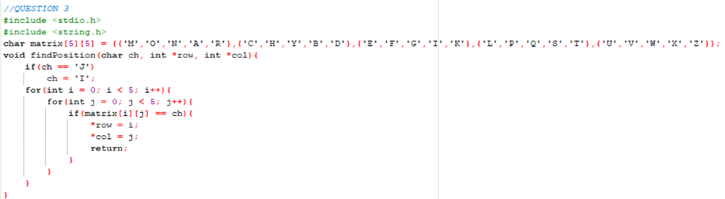
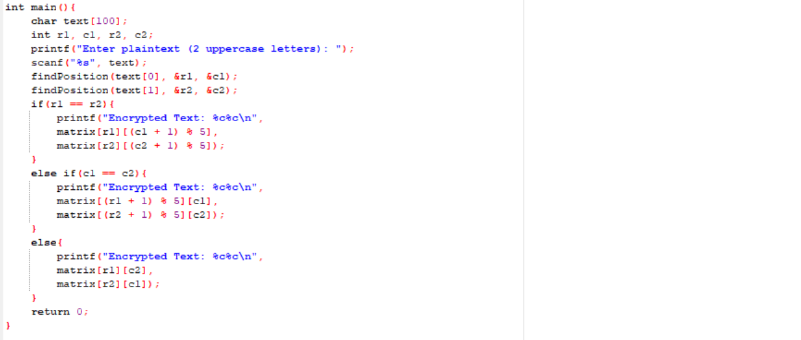

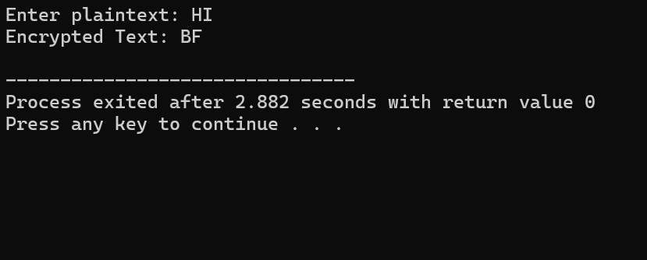

- Write a C program for polyalphabetic substitution cipher uses a separate monoalphabetic substitution cipher for each successive letter of plaintext, depending on a key.
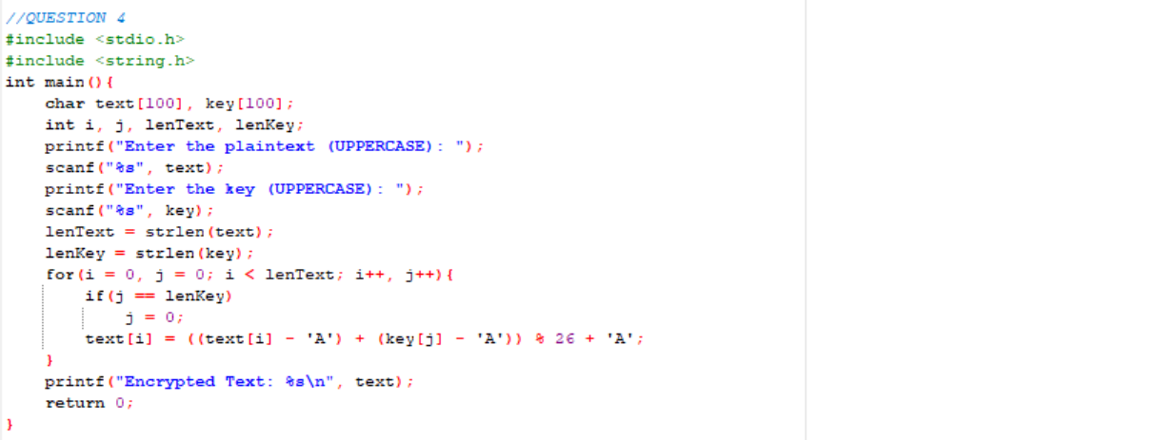
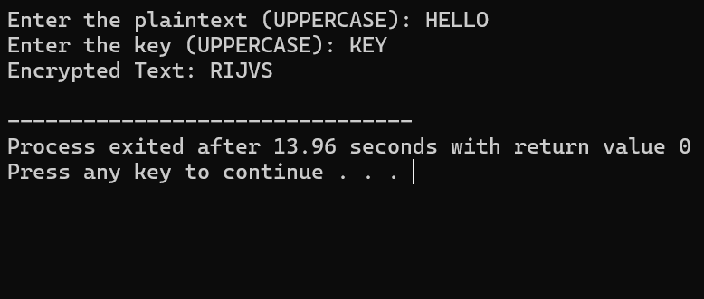

- Write a C program for generalization of the Caesar cipher, known as the affine Caesar cipher, has the following form: For each plaintext letter p, substitute the ciphertext letter C: C = E([a, b], p) = (ap + b) mod 26 A basic requirement of any encryption algorithm is that it be one-to-one. That is, if p q, then E(k, p) E(k, q). Otherwise, decryption is impossible, because more than one plaintext character maps into the same ciphertext character. The affine Caesar cipher is not one-to-one for all values of a. For example, for a = 2 and b = 3, then E([a, b], 0) = E([a, b], 13) = 3. a. Are there any limitations on the value of b? b. Determine which values of a are not allowed.
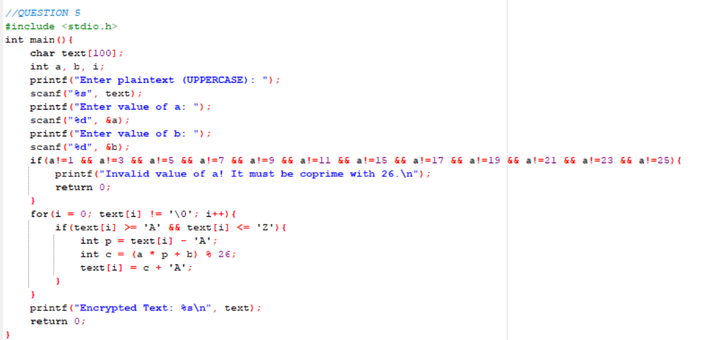
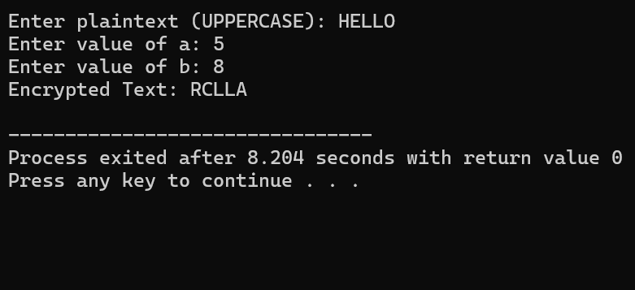

- Write a C program for ciphertext has been generated with an affine cipher. The most frequent letter of the ciphertext is “B,” and the second most frequent letter of the ciphertext is “U”. Break this code.
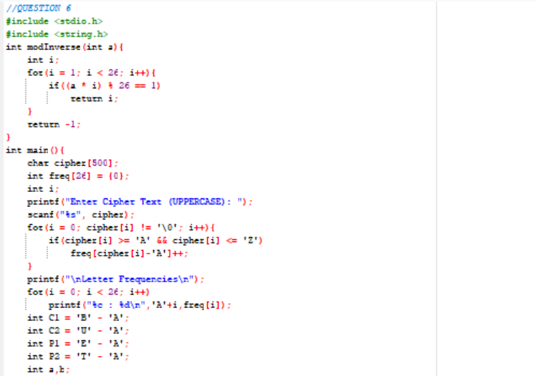
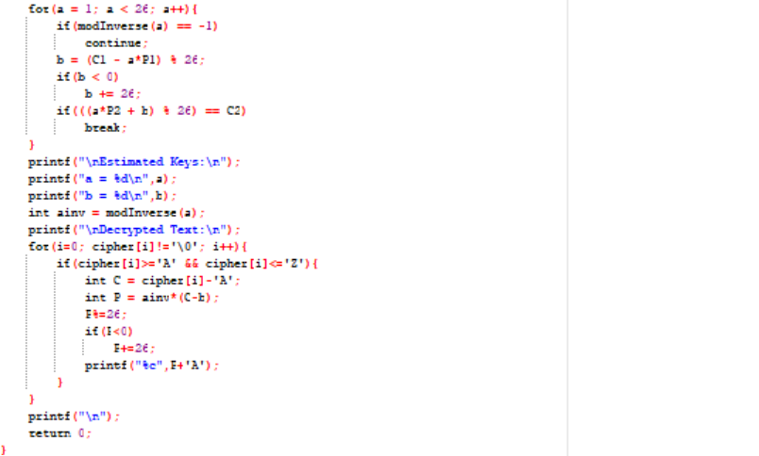
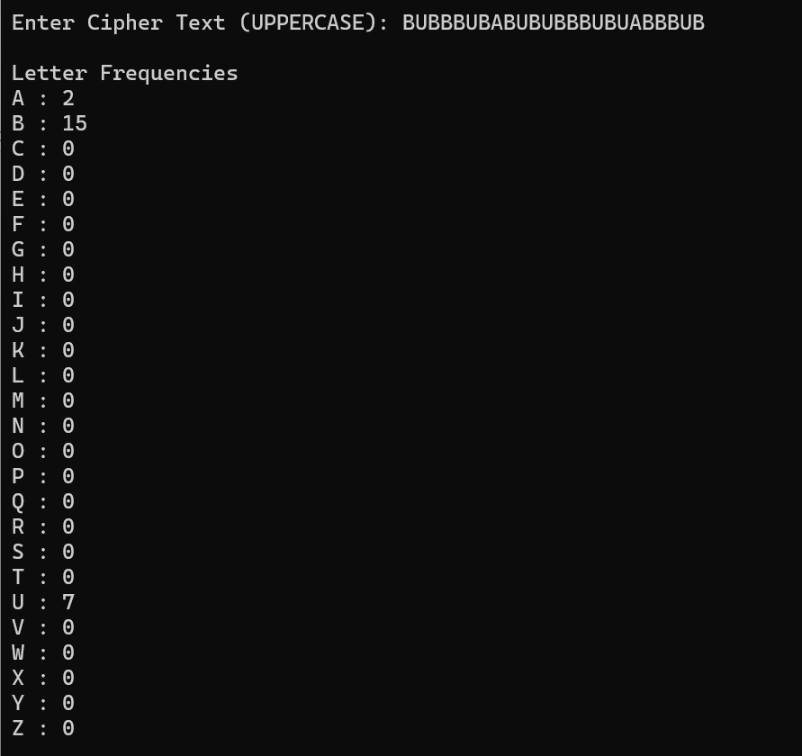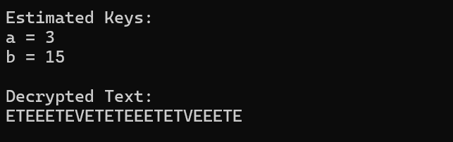

7. Write a C program for the following ciphertext was generated using a simple substitution algorithm. 53‡‡†305))6*;4826)4‡.)4‡);806*;48†8¶60))85;;]8*;:‡*8†83(88)5*†;46(;88*96*?;8)*‡(;485);5*†2:*‡(;4956*2(5*—4)8¶8*;4069285);)6†8)4‡‡;1(‡9;48081;8:8‡1;48†85;4)485†528806*81 (‡9;48;(88;4(‡?34;48)4‡;161;:188;‡?;
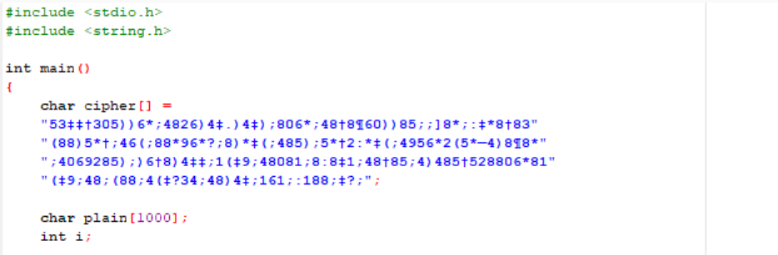
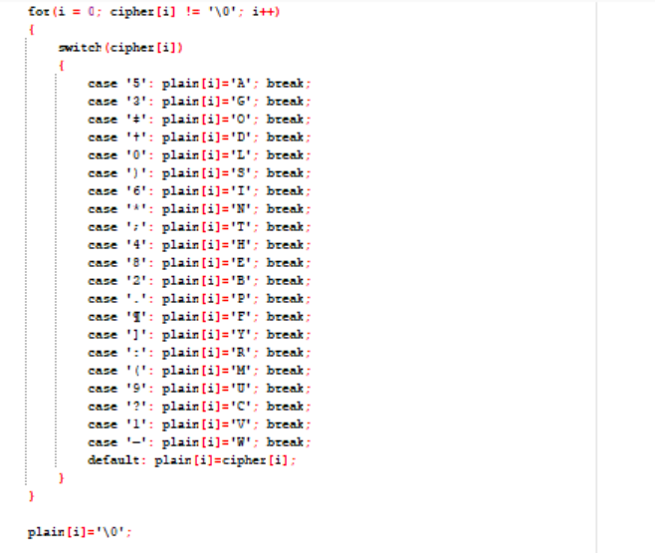
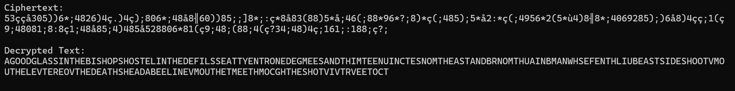
8. Write a C program for monoalphabetic cipher is that both sender and receiver must commit the permuted cipher sequence to memory. A common technique for avoiding this is to use a keyword from which the cipher sequence can be generated. For example, using the keyword CIPHER, write out the keyword followed by unused letters in normal order and match this against the plaintext letters: plain: a b c d e f g h i j k l m n o p q r s t u v w x y z cipher: C I P H E R A B D F G J K L M N O Q S T U V W X Y Z
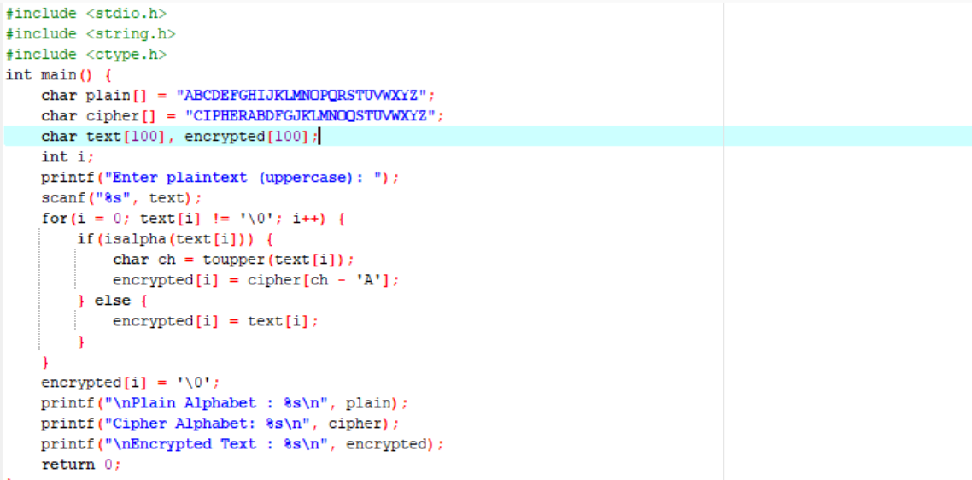
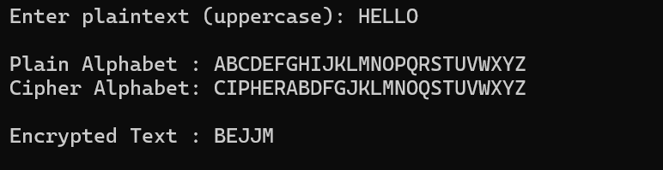
9. Write a C program for PT-109 American patrol boat, under the command of Lieutenant John F. Kennedy, was sunk by a Japanese destroyer, a message was received at an Australian wireless station in Playfair code:
KXJEY UREBE ZWEHE WRYTU HEYFS
KREHE GOYFI WTTTU OLKSY CAJPO
BOTEI ZONTX BYBNT GONEY CUZWR
GDSON SXBOU YWRHE BAAHY USEDQ
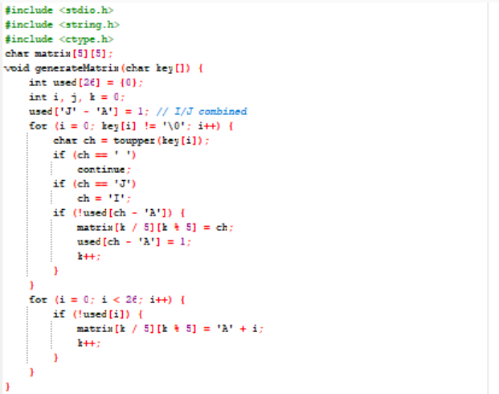
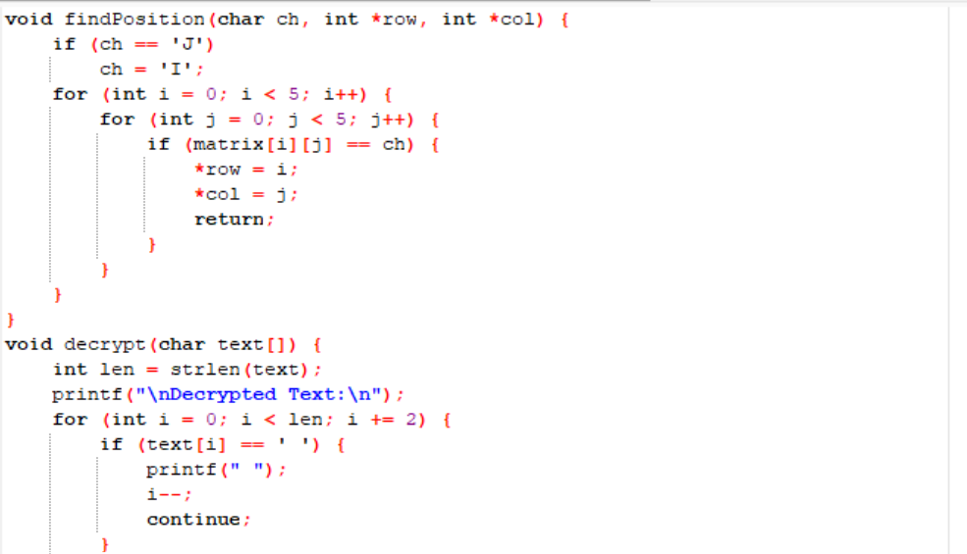
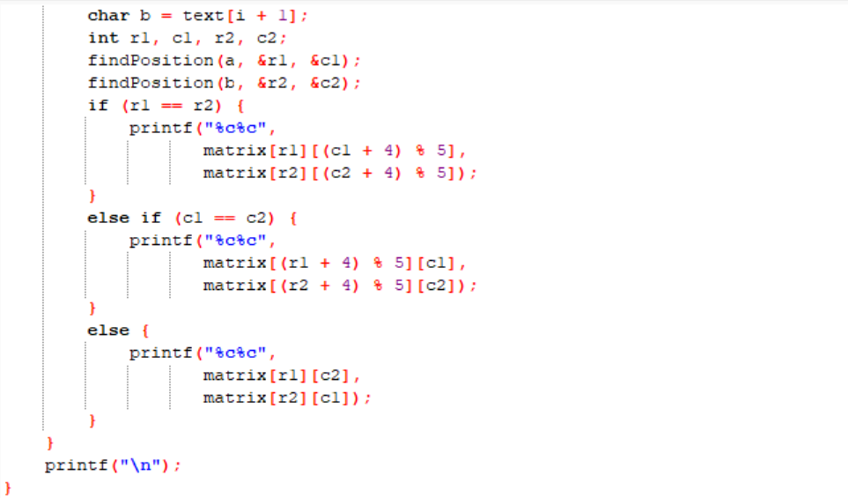
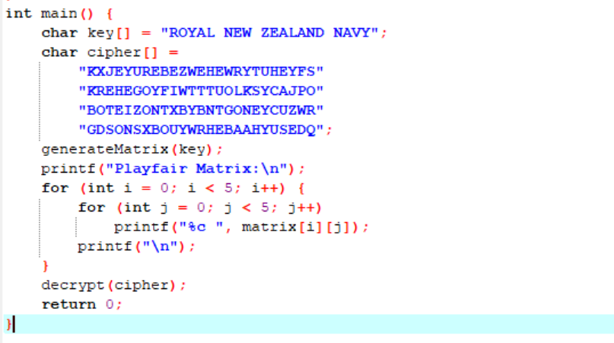
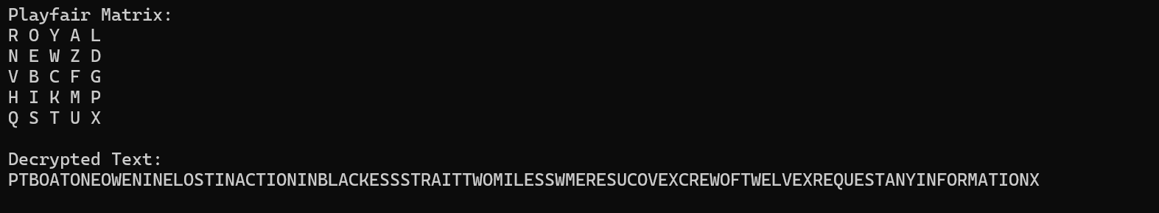
10. Write a C program for Playfair matrix:
M F H I/J K
U N O P Q
Z V W X Y
E L A R G
D S T B C
Encrypt this message: Must see you over Cadogan West. Coming at once.
